**Artificial Intelligence Summer 2019 Homework 2: Adversarial Search**

# Please follow this format for submission. You may reproduce it in LaTeX or word if you wish

# Name:

# UNI:

_______________________________________________________________________________________

# WRITTEN

# Please justify all your answers to receive full credit (unless stated otherwise). There are 3 questions.

## **Question 1: Minimax and Alpha-Beta Pruning (10 points)**

Consider the following game tree. Let A through F be real numbers. We explore the nodes with minimax and alpha-beta pruning.

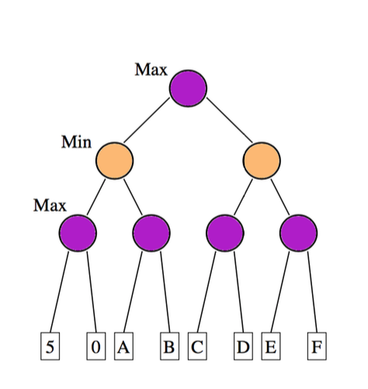

* 1. Give a domain for A, so B is pruned.
  2. Let A = B = 5. Suggest values for C and D such as the subtree with children E and F is pruned.

## **Question 2: (10 points)**

## Consider a dataset with 90 negative examples and 10 positive examples.

## Explain the problem you might encounter when you use KNN on this dataset.

1. Suppose a model built using this data predicts 30 of the examples as positive (only 10 of them are actually positive) and 70 as negative. What are the numbers of True Positives (TP), False Positives (FP), True Negatives (TN), and False Negatives (FN).
2. What measure derived from these numbers can help detect the poor prediction ability of the model? Consider the measures of accuracy, precision, recall, specificity defined below. Justify your choice.

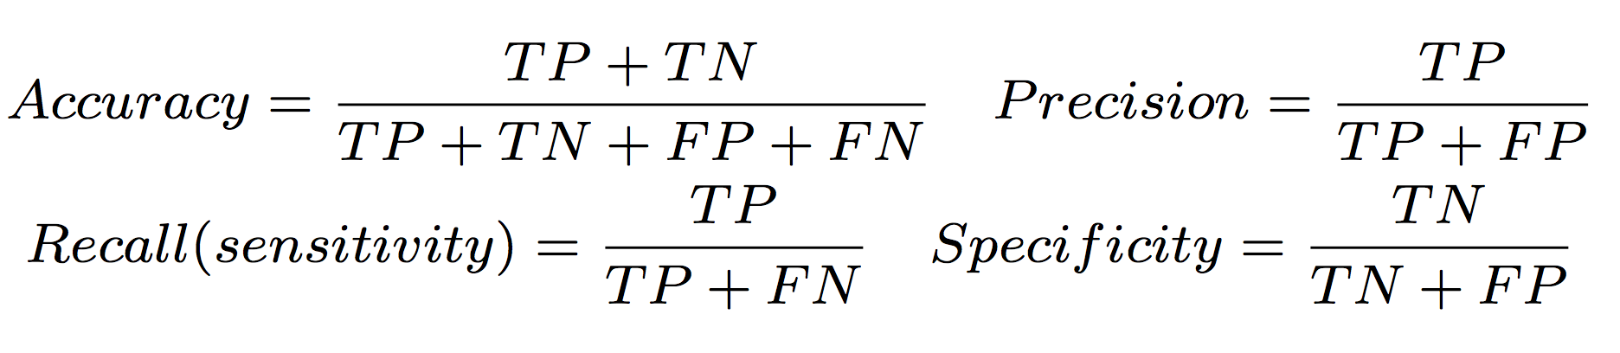



## **Question 3: Linear regression (10 points)**

Consider the small dataset below. We would like to perform a linear regression y = β0 + β1 x

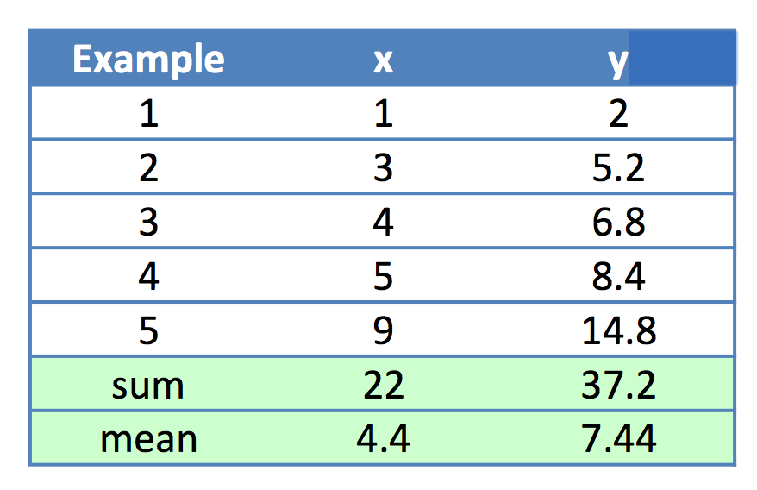

1. Solve for β0 and β1 using the formulas seen in class. Then write the equation of the regression line.

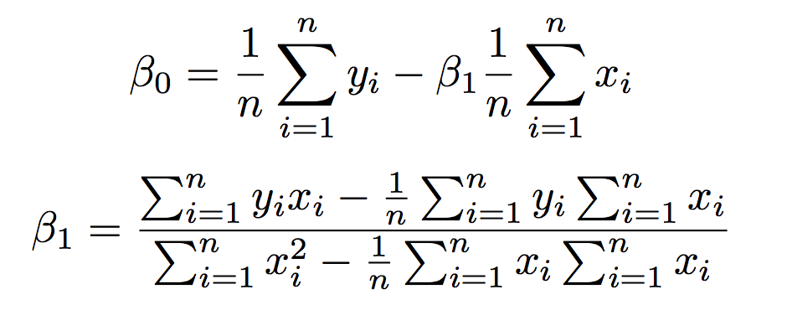

2. What would be the predicted y of a new example with x = 6?

## **Question 4: Checkers is solved!** **(10 points)**

Please read the research article Checkers Is Solved by Schaeffer et al. 2007:

<https://courseworks2.columbia.edu/courses/82461/files/folder/READING?preview=4827635>

Describe in the space below how checkers were solved. Explain what methods were used and how. You can provide a general algorithm or specific explanations. Use your best judgement to provide the key elements.